Programming Assignment 2 Report

(SERP Simulator 2.0)

Yang (Liam) Li

CS146-S7

1)Installation(p2)

2) Software Design(p3)

3) Implementation (p4 – p10)

4)Features/Functions/Classes

(p11 – p17)

5) Testing (p18 – p19)

6) Problems (p20)

7) Learnings (p20)

**1) Installation**

* Unzip the zip folder, there are three part, an SRC folder that contains all of the .java files, a Program Report which is this Microsoft Word Document you are reading it now and a runnable .jar file called “Google Search2”.
* Open the jar file and start testing! Warning: if you have the alert the “can’t be opened because it is from an unidentified developer”, go to the System Preference -> Security and Privacy -> General -> Allowed apps downloaded from and let this app open!
* You can modify the code, or compile/run by yourself, you can simply create a **Java FX projects** in any IDE (Eclipse and IntelliJ are tested and highly recommended) and copy the files from SRC folder to your project.

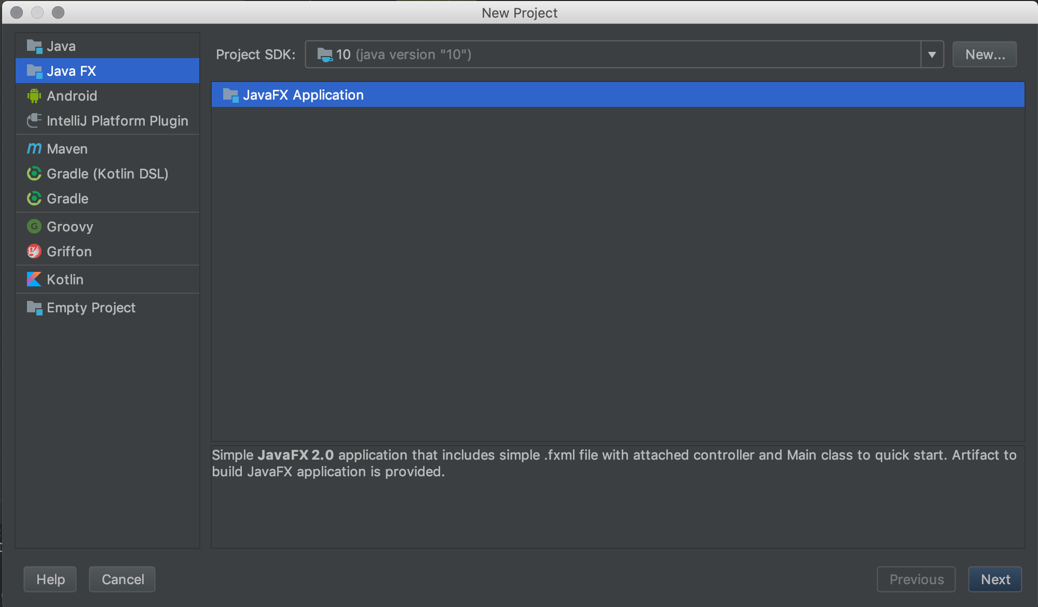

* This program is using JSOUP library to web crawl the results from google search, you need to download JSOUP whether in Marven or I have downloaded the library for you, simply **click the file -> Project Structure ->Project Settings ->Libraries ->click the plus symbol and select the JSOUP Zip file in the same folder as the SRC files(Only if the JSOUP library is not imported yet) -> click OK -> All the needed external things are installed.**

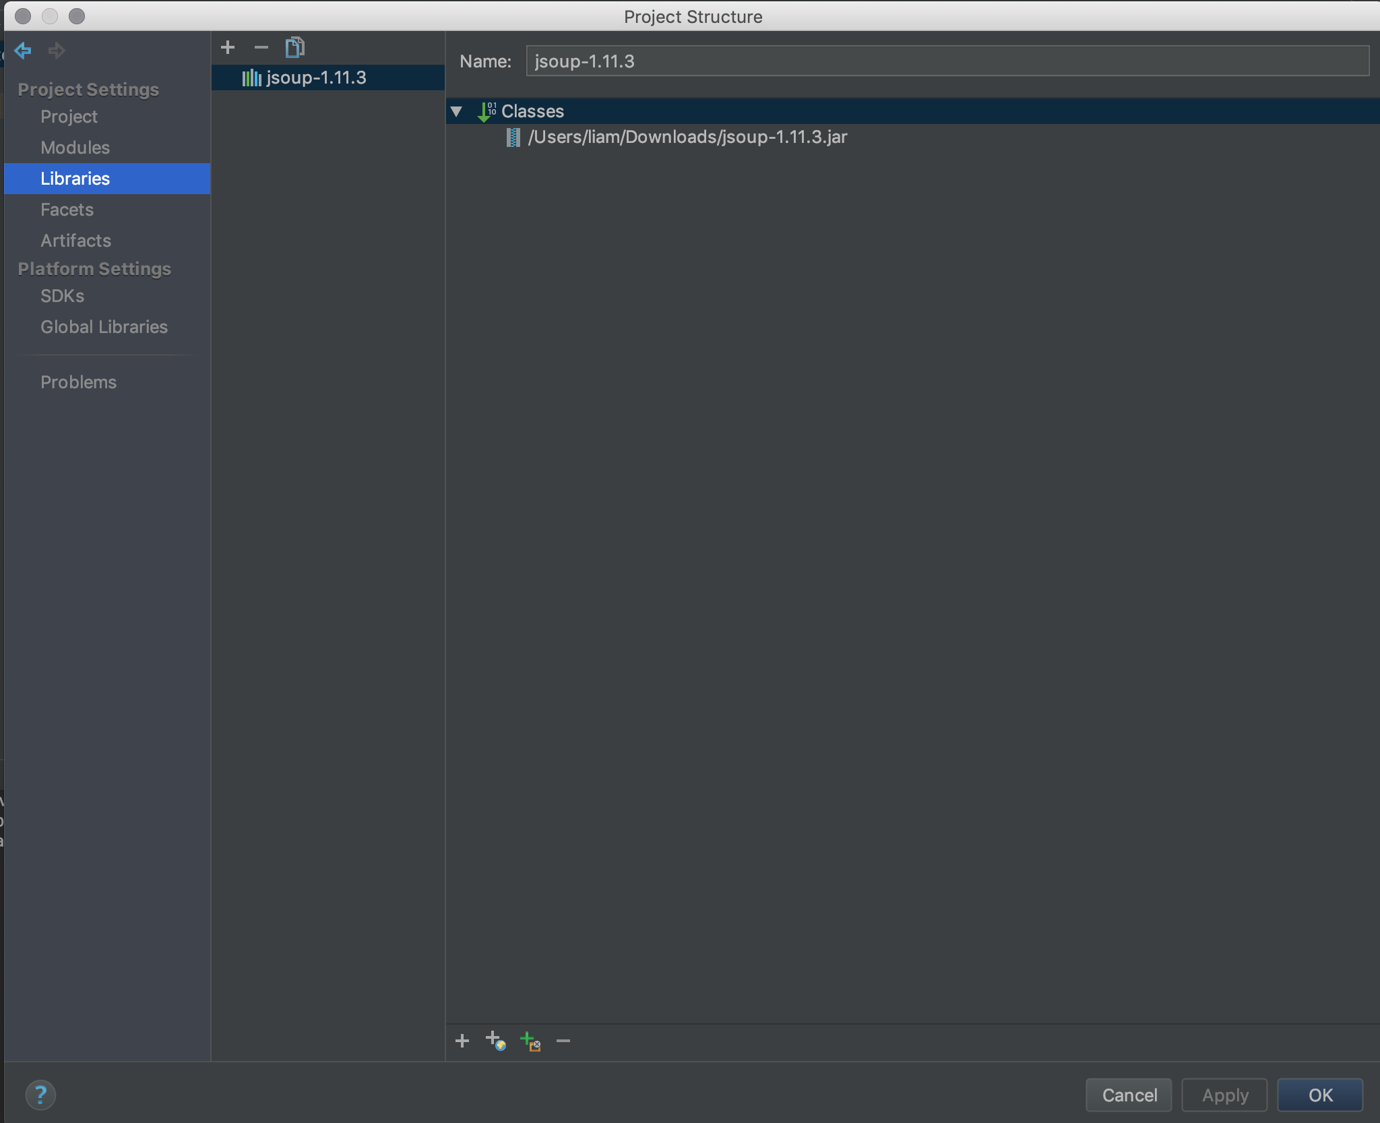

**2) Software Design**

1. Using JavaFX to create the UI part of this program
2. Using JSOUP library to web crawl the searches from google search
3. Create a search Class called Node.java that store the variables including title, URL, position, 4 factors, total scores, PageRank, index, count, keyword, company name and left, right, parent nodes of itself and able to set them and get them.
4. Create a Quick.java can sort the results by the total score.
5. Create a BST file that called BinarySearchTree.java that build up the tree by inserting results one by one to the tree. Having Insert, Delete, search features by the tree

6. By using the JavaFX, create three main scenes, that can show the 30 results, user can search the result by PageRank, insert result by URL and 4 scores, delete result by URL or total score.

**3) Implementation**

1. **Main scene (Scene 1)**

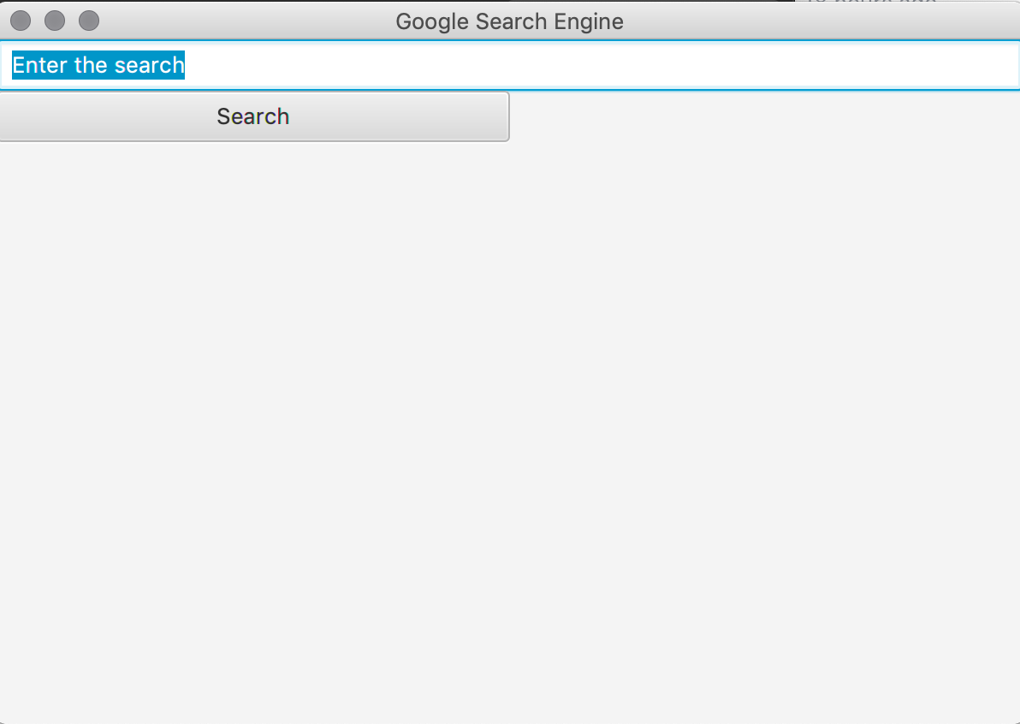

Text Field: Enter the keyword that you want to search

Search Button: have the setOnAction event, when it clicked, getting the Keyword (String) from the Text Field Above, and calling the web crawl function by using JSOUP library, getting 30 results from google search, and store each’s properties into an object called Node as ArrayList called nodeList, and changing this ArrayList into a quick Class and doing the showing the result by doing quick sort and able to display them from highest total Scores(lowest PageRank) to lowest total scores(highest PageRank) in second scene.

1. **Display all 30 results in second scene (scene 2)**

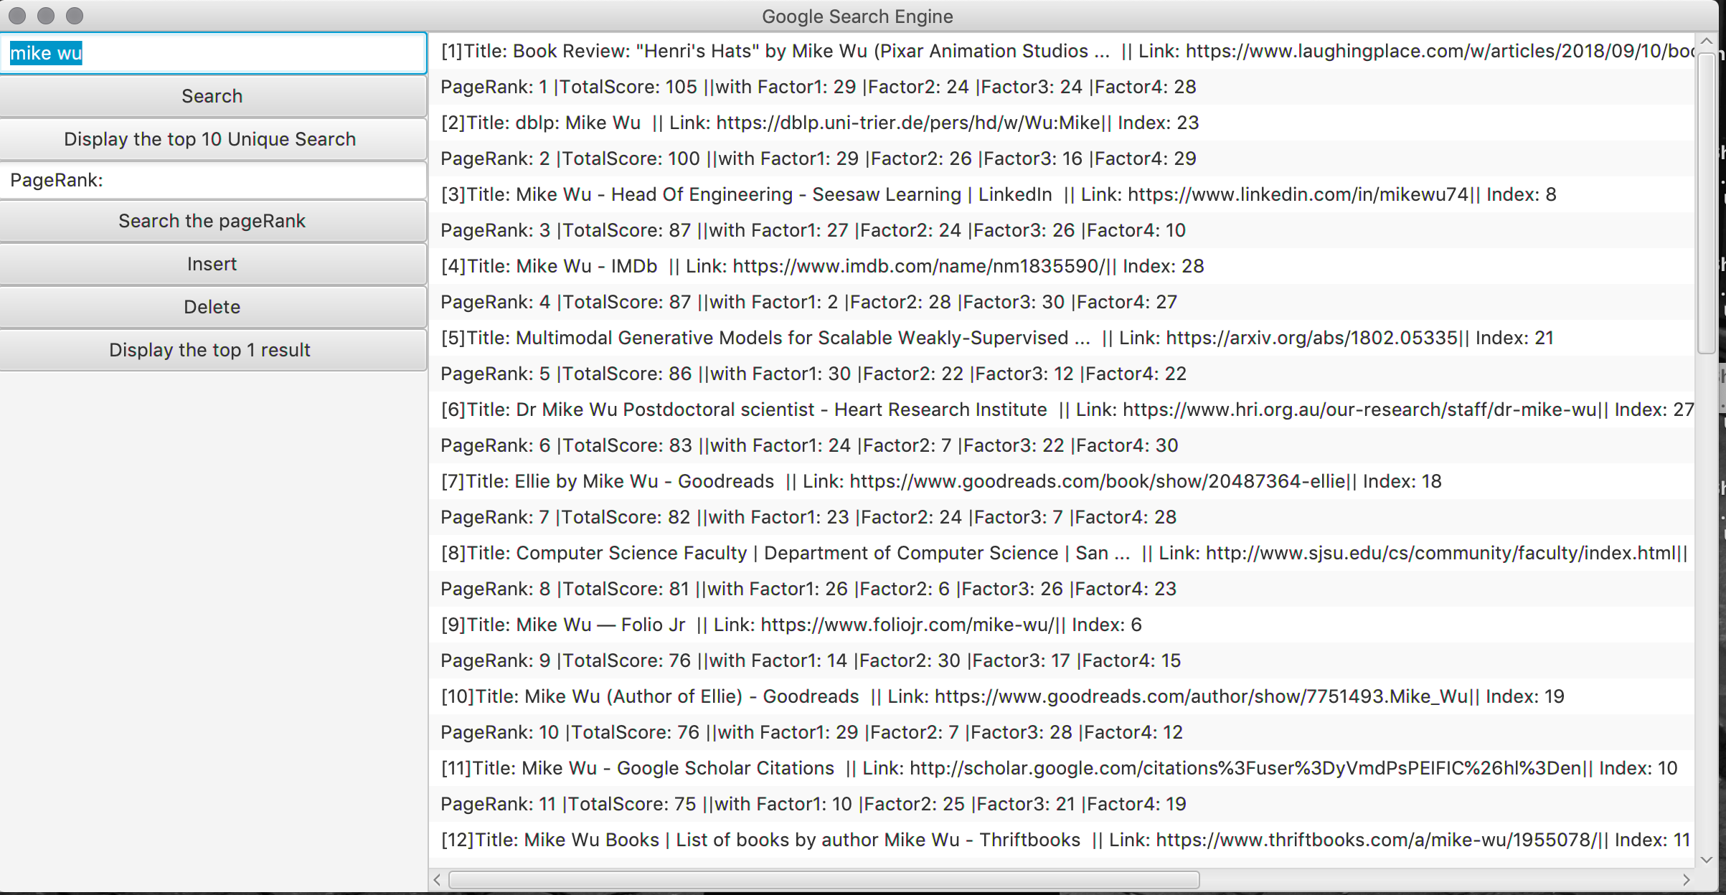

The Second Scene have the left view and right view, left View contain the Text Field and Search Button that you research whatever you want, and additional One Text Field and Five buttons:

1) Button (Display the top 10 Unique Searches): Display the top Unique Search, I would talk about this next scene – **Scene 3**

2) Text Field: Let user enter the PageRank that they want – **Scene 4**

3) Button (Search the PageRank): Display the result of user selected URL based on the PageRank – **Scene 4**

4) Button (Insert): Show the UI that let user insert a result by entering URL and Scores

- **Scene 5**

5) Button (Delete): Show the UI that let user delete the URL based on the PageRank. – **Scene6**

6) Button (Display the top 1 Result): Display the search result of the first unique keyword.

**Scene 7**

1. **Display the top 10 unique searches (Scene 3)**

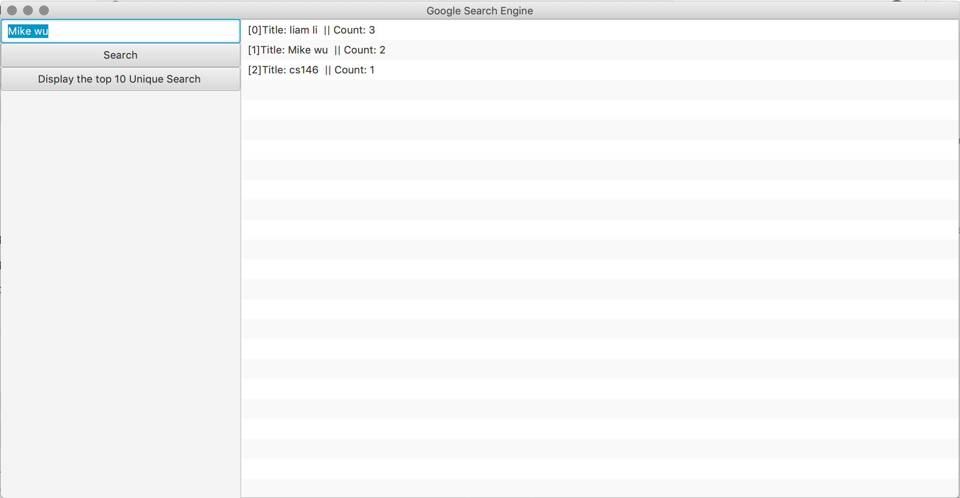

I search my name “liam li” for 3 times, “Mike wu” for 2 times and “cs146” only one time, these keywords and count are stored automatically every time I clicked the “search” button into Node. When I clicked the “Display the top 10 Unique Search”, it added the object into a new ArrayList called “uniqueArrayList”, and sort them from highest count to lowest count using insertion sort. Because insertion sort is less memory, sorted in place.

**4. Search the PageRank (Scene 4)**

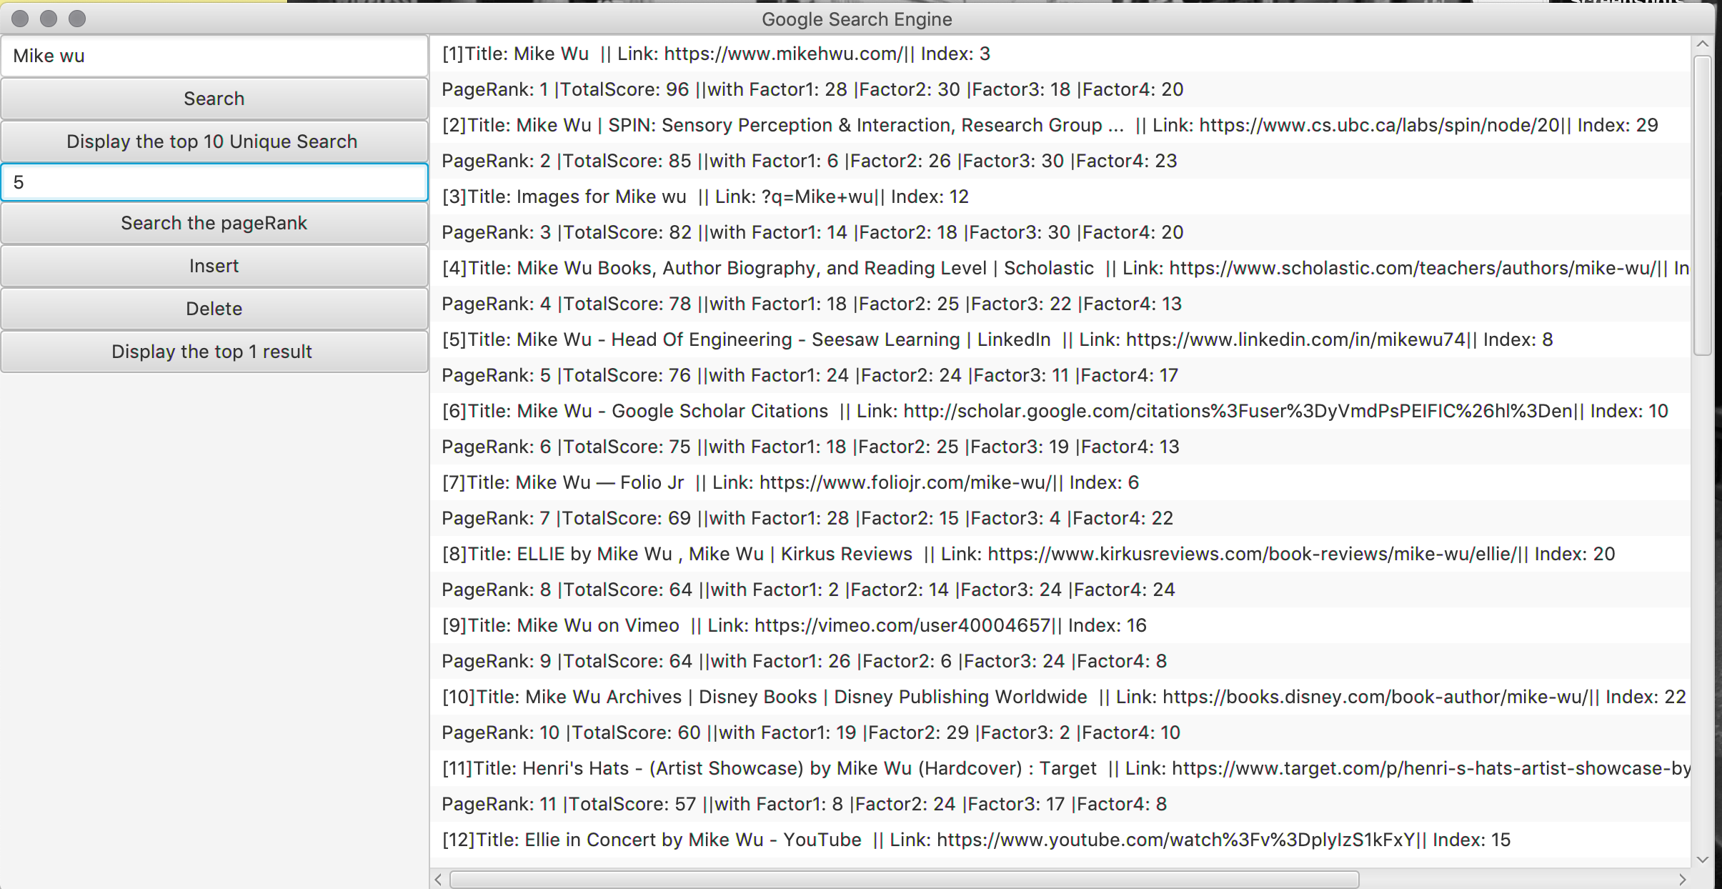

As you can see, I try to search the PageRank with 5 and it should display the result same as this



Once I clicked the “Search the PageRank” button, it create a Node that have the PageRank and find the total Score from the ArrayList from the QuickSort, then return the exacte Node that can allow me to using the BST to search the Node and return the Node, then display the result to the ListView

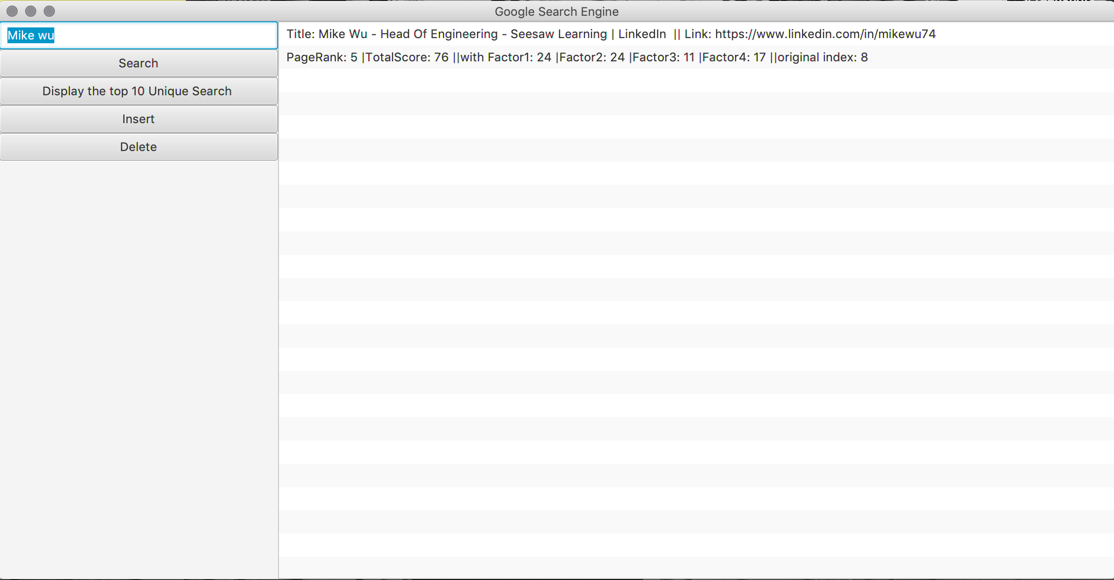

**5. Insert a result (Scene 5)**

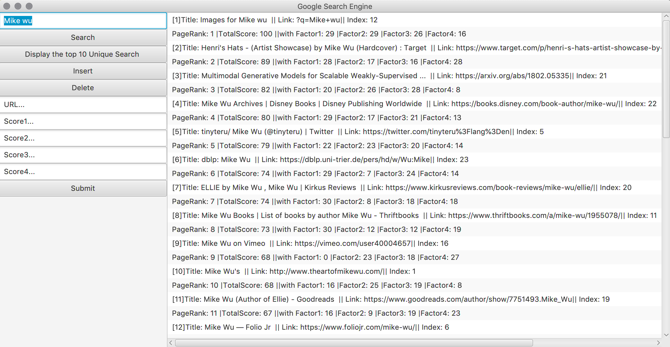

As you can see, once the insert button is clicked, the left view have 5 inputs Text Fields, that can let user enter the URL and 4 scores of the website. For example would be below:  
I inserted

URL: [www.ilovemikewu.com](http://www.ilovemikewu.com)

Score1: 100

Score2: 200

Score3: 300

Score4: 400

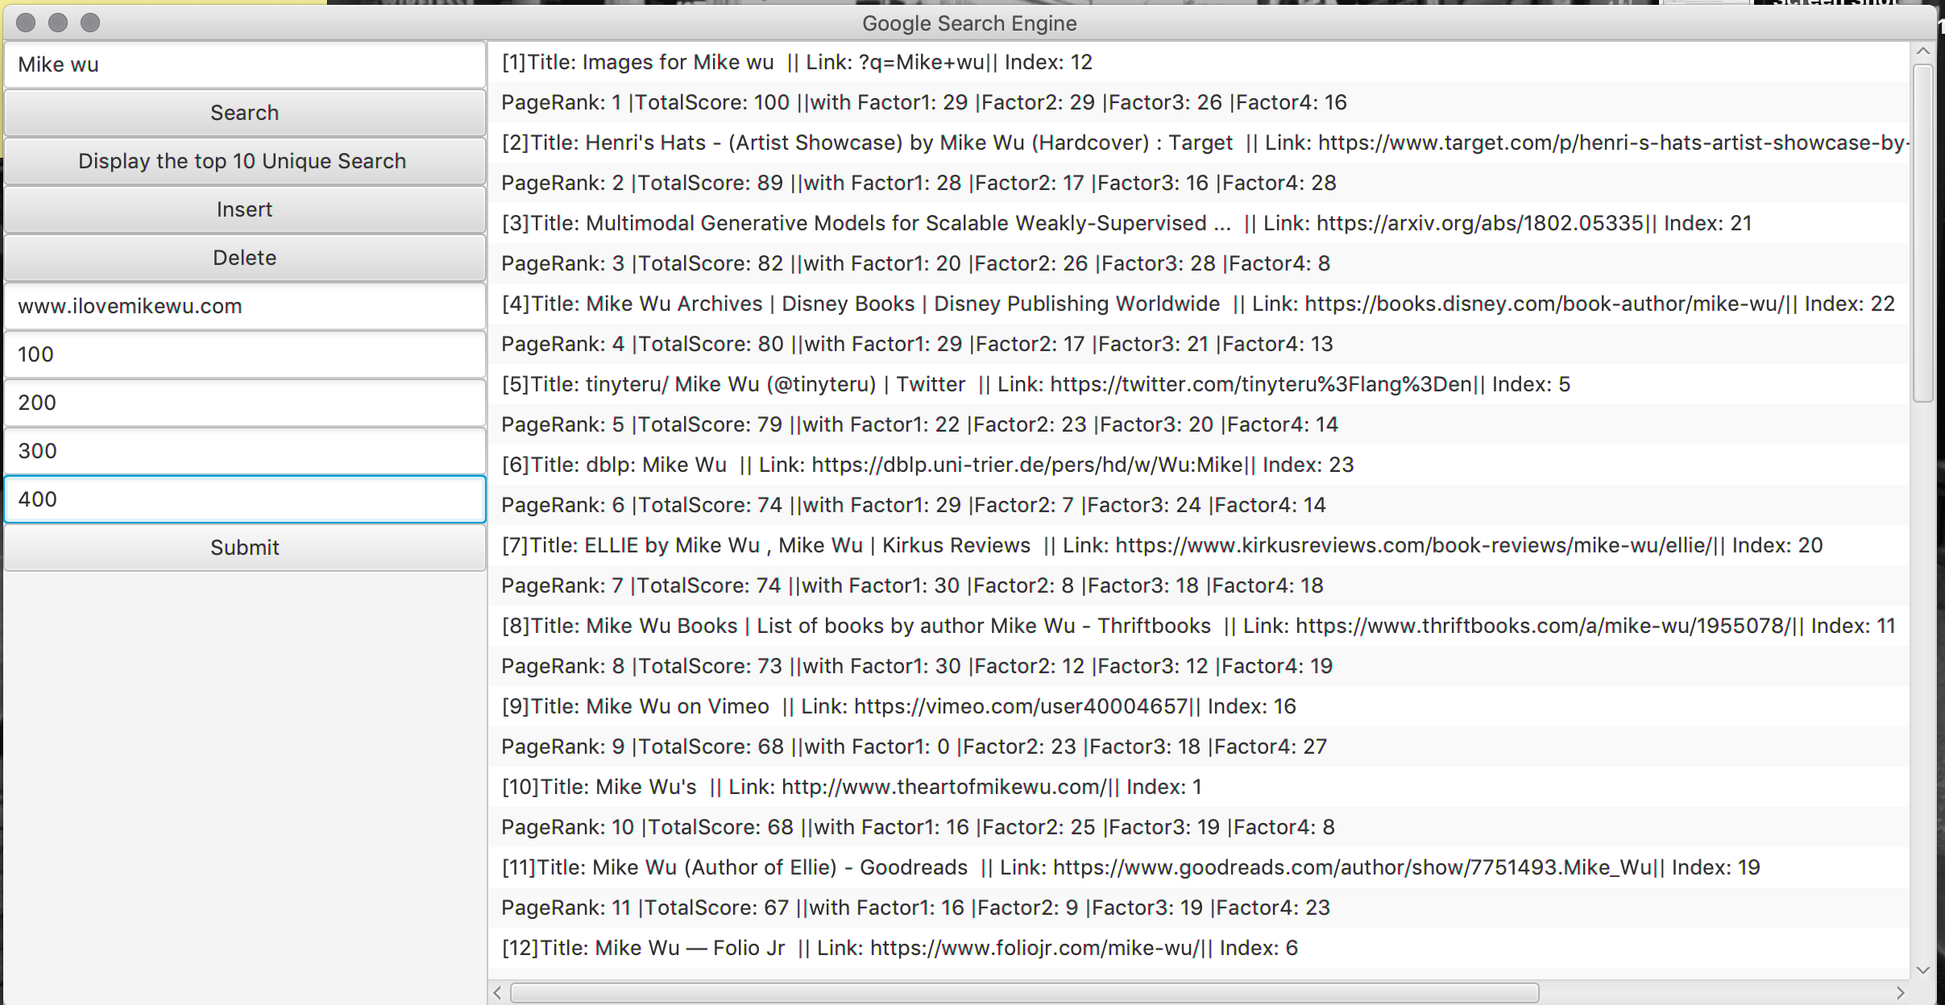

Now, Let’s see what happen once I click the submit button.

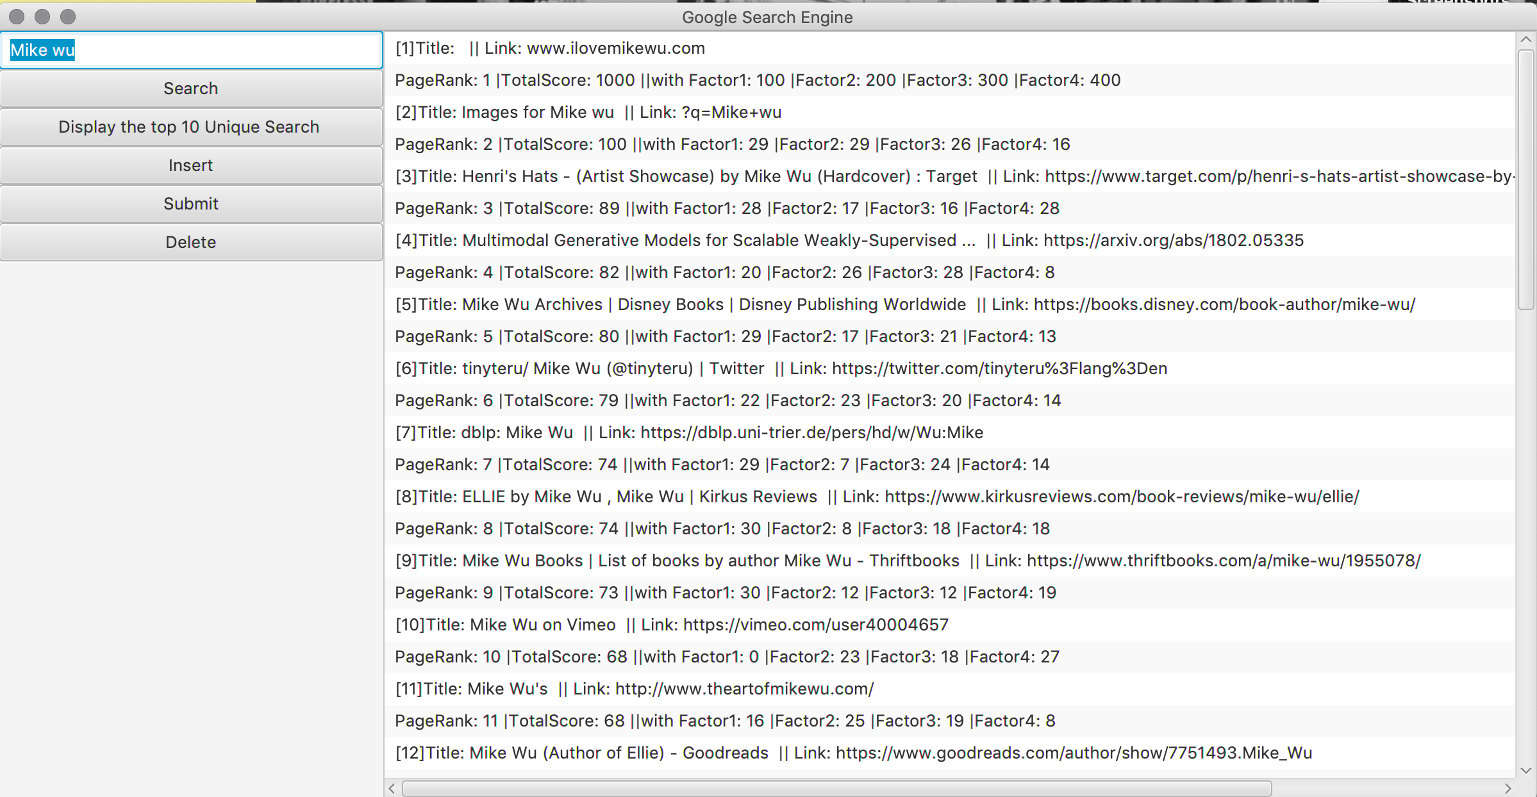

Look at the right List View, you can see the first result have the values that I input.

**6. Delete a result (Scene 6)**

Once I click the “Delete” button, it shows us the left view that let user enter URL and PageRank. Users can actually input either URL or PageRank, depends on what information that the user knows. Users can input the URL without PageRank, or input PageRank without URL, the program is able to delete the result ☺.

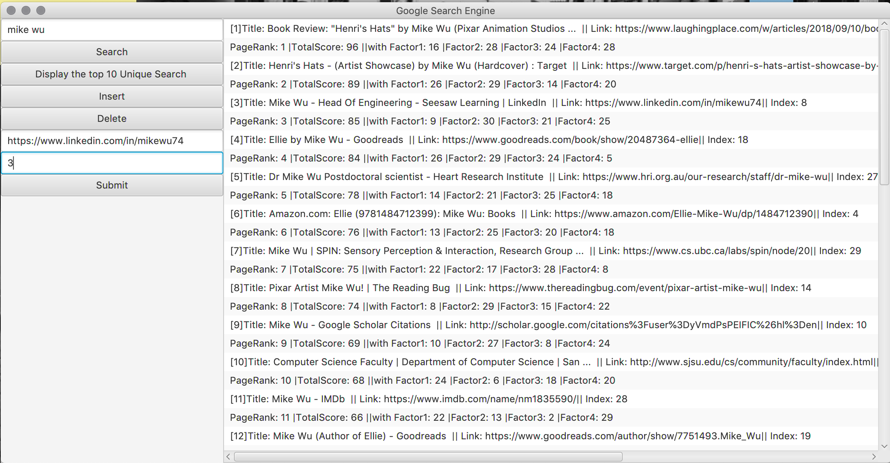

I choose the PageRank 3 and the URL of that. The results view should not have the result like below



Once I click submit, the deleted result is not showing up on the right view anymore!

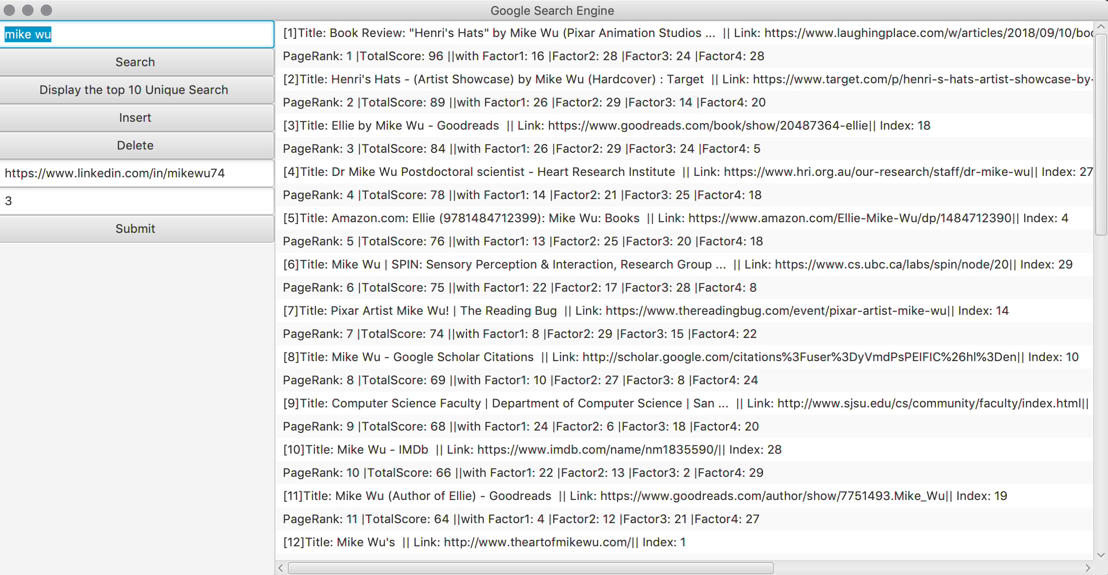

**7. Display the top 1 Result (Scene 7)**

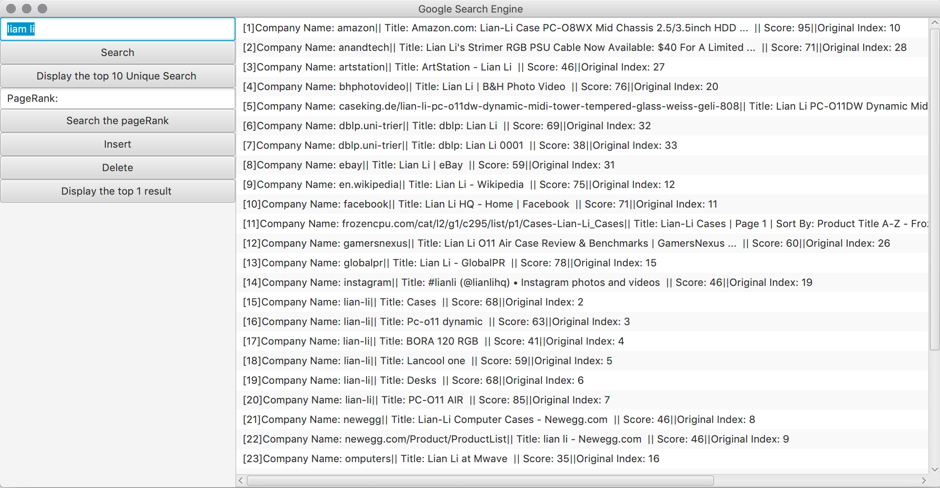

Once I clicked the “Display the top 1 result” button, the List View changed like above. The company name is sorted in Alphabet order using the bucket sort.

The 7 scenes have showed all of the main features and function of this program. Now, let’s deep into each file and see how each function does.

**4) Features/Functions/Classes**

**Main.java**

* Web crawler: Using JSOUP to connect the URL and setting the userAgent, from the div of the google search website, we know the search result is contained in the div of h3, so we can just only get what we want from the div of h3.
* UI components: ListView, Button, TestField



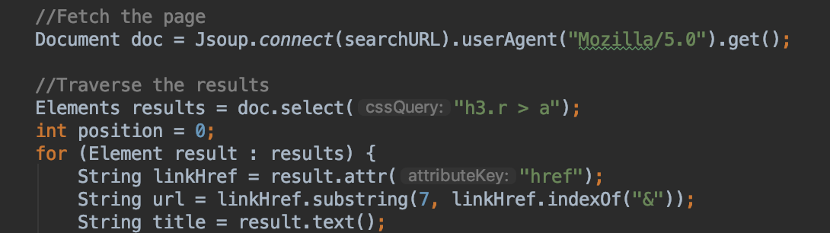

In Order Tree Walk, be able to travel the tree in order and return it as an ArrayList

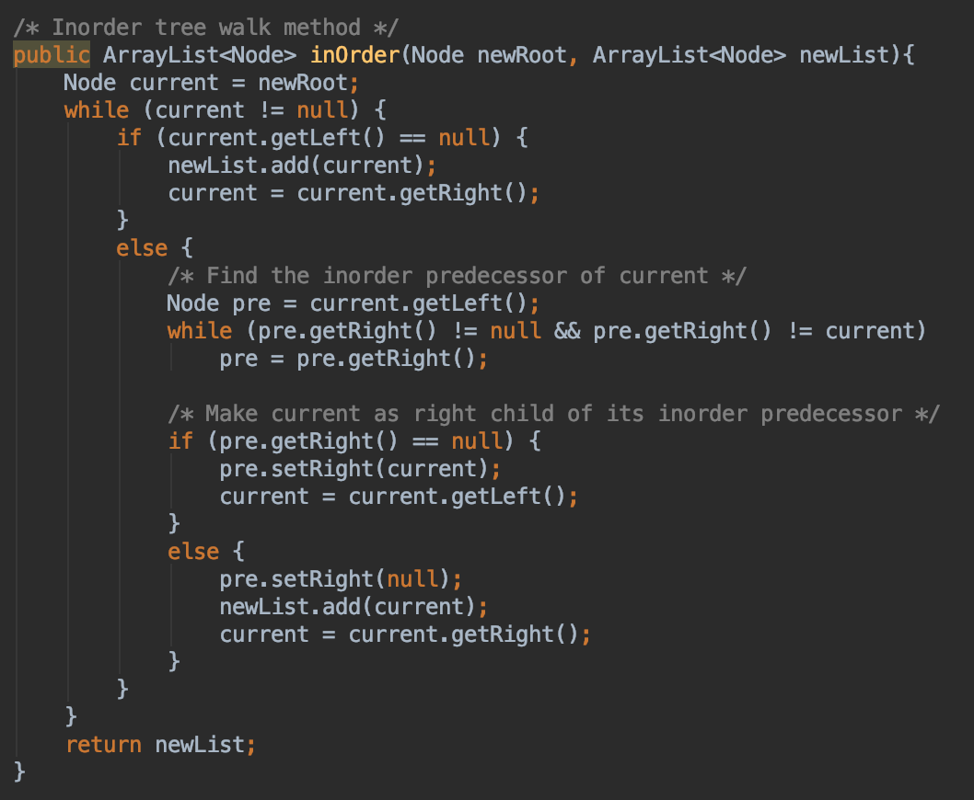

GetHostName: taking the URL as parameter and return it as the company name or host name. Self-observing the patterns by many, many URLs without using any library.

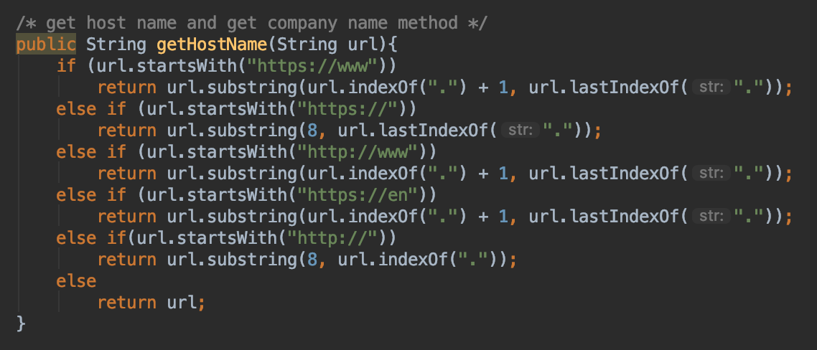

**Quick.java**

Quicksort: get the initial Partition and doing quicksort recursively

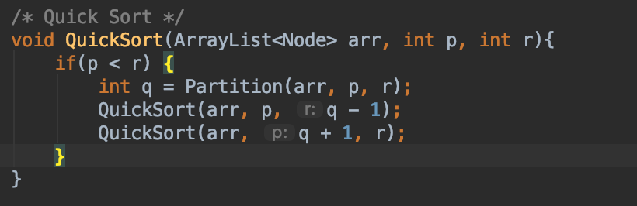

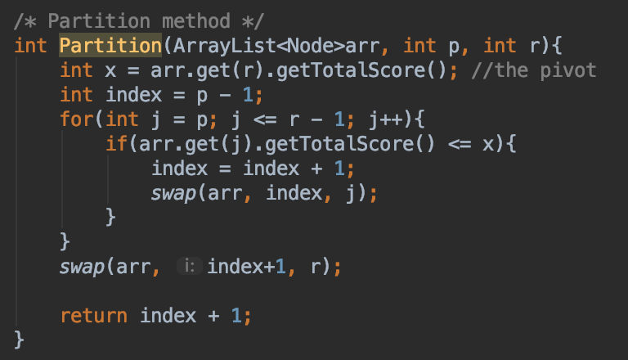

Swap method: swap the two Node

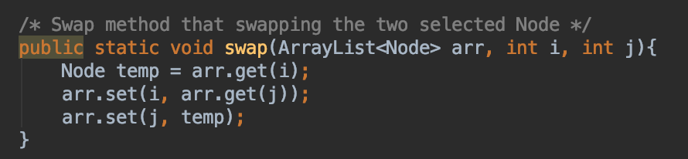

**BinarySearchTree.java**

Tree minimum: return the smallest element by get the very end of the left tree

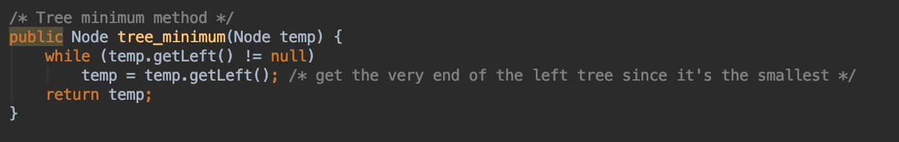

Tree maximum: return the largest element by get the very end of the right tree

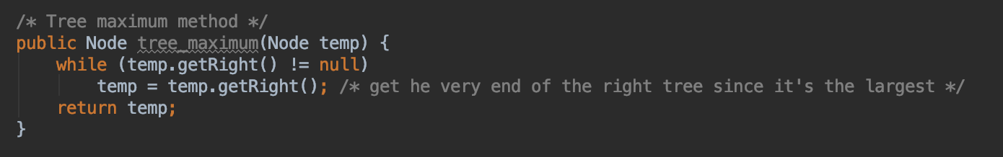

Tree successor: The smallest element of the right tree

1) return the minimum of right tree if the right node of the temp is not null

2) create a Node y that equal to the temp’s parent, and while the y is not equal to the null and the right node of y equal to the temp node. Then set temp node equal to y, and y equal to its parent node. Return the y.

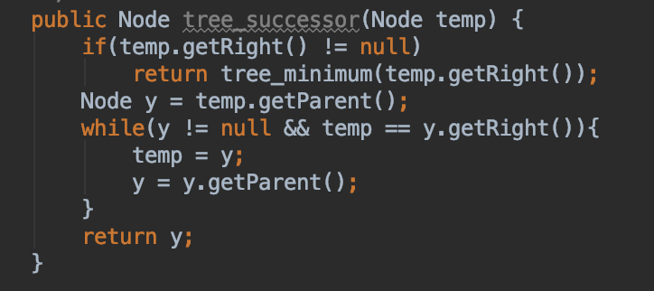

Tree transplant: restructure the tree by reconnect new parent and new child. Usually use it for delete method with 3 different cases.

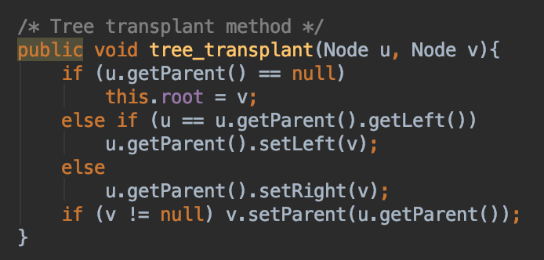

Tree search: search the targeted node recursively

1) found it, return

2) (key) less than, go to the left tree.

3) (key) greater than, go to the right tree.

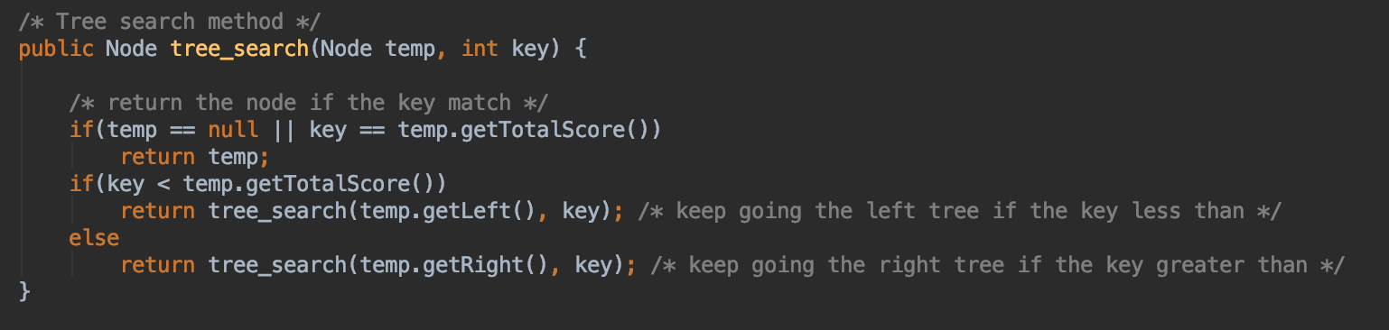

Tree insert: insert the targeted node. Just like tree search, insert it from the root and go to left if less than while go to right if greater than.

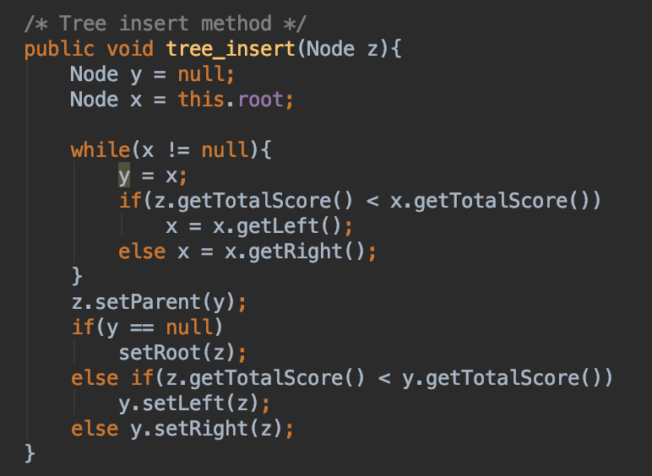

Tree delete: delete the targeted node with 3 difference cases and each case also have 3 different transplant cases.

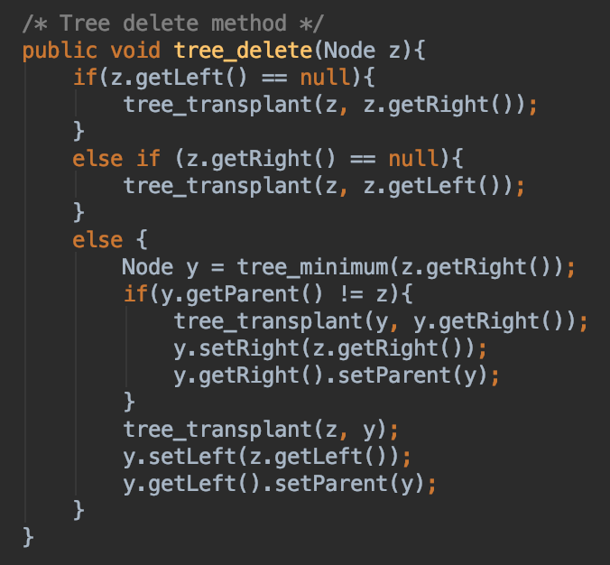

**Node.java**

Having all the information of one result. Total score equal to the sum of 4 scores. The count equal to the number of user enter the search, the number of the “search” of one specify keyword

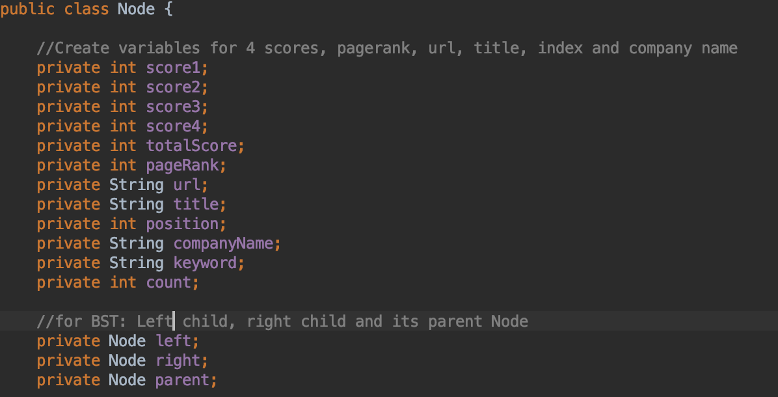

**UniqueSort.java**

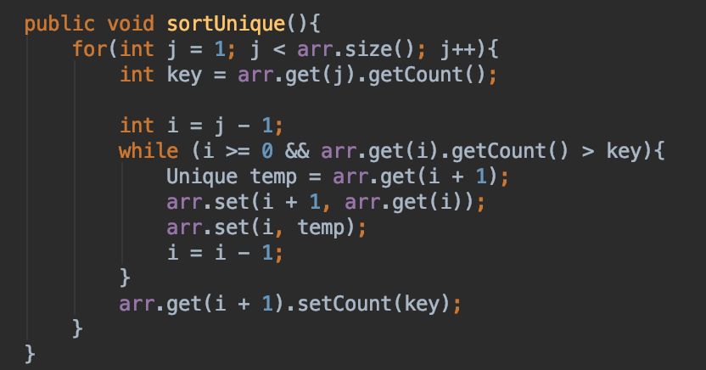

Contains the sort function to sort the count times for Unique Keyword using the insertion sort as the Code from Homework 1/ Textbook.

**BucketSort.java**

Bucket sort:

1) Create buckets (ArrayList) and each bucket contain an ArrayList

2) Create the size of the buckets since the alphabet only have 26 char

3) Initialize each bucket with a new ArrayList (first for loop)

4) Put the incoming company name to targeted bucket (second for loop)

5) Insert sort for each bucket (third for loop)

6) Create the final ArrayList to store the ordered data

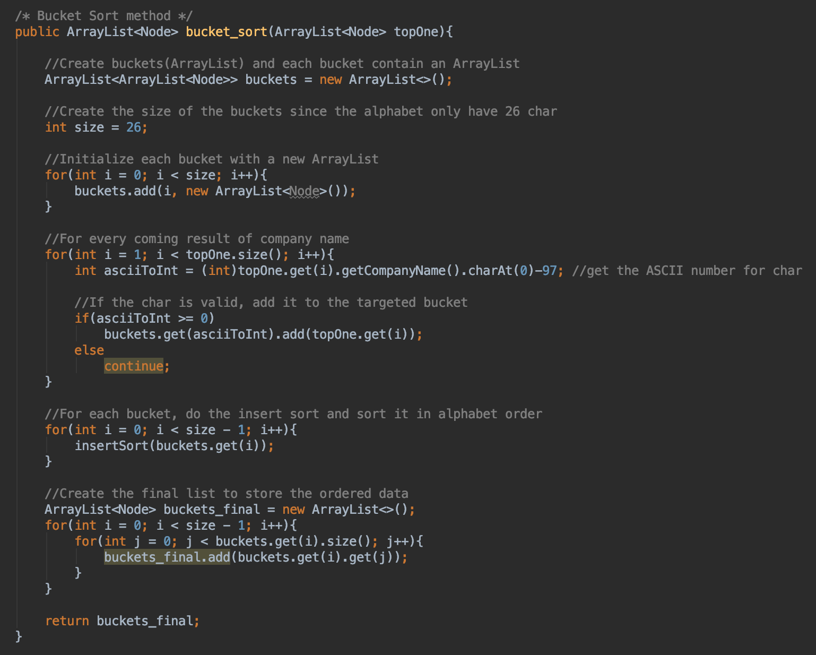

Insertion sort: using the insertion sort from hwk1 but change the comparison method to comperTo because it compare strings.

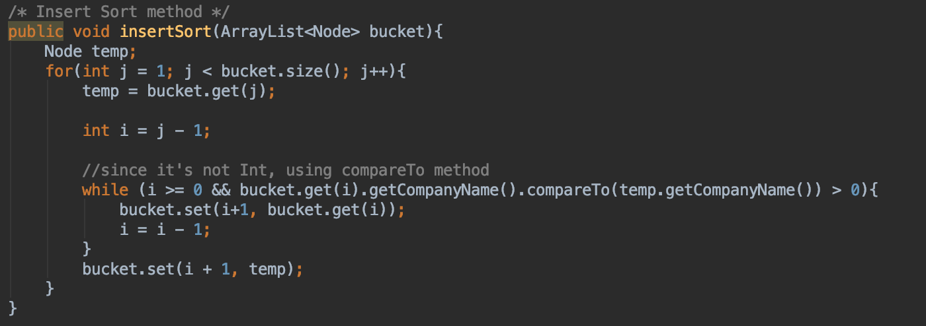

**5) Testing**

I create a test class called test.java that test all of the sorting algorithm and BST tree method from above.

1)Testing quick sort and BST with insert and delete

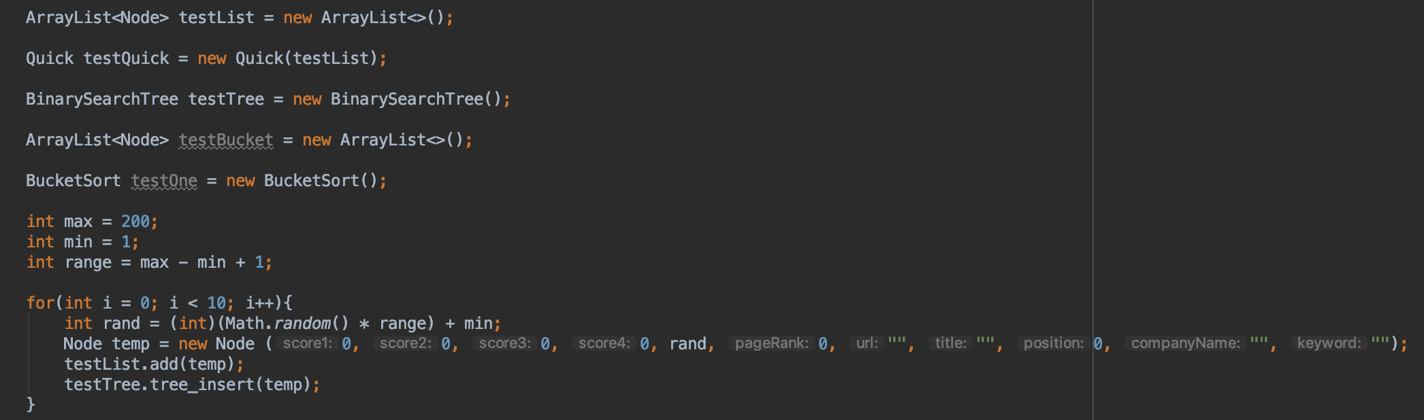

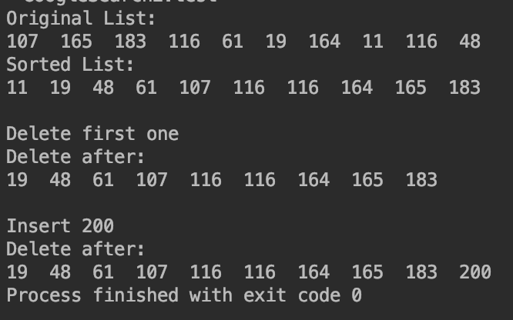

Creating math random number for total score and store it to ArrayList, calling quicksort, BST delete, and BST insert.

2)Bucket Sort Testing

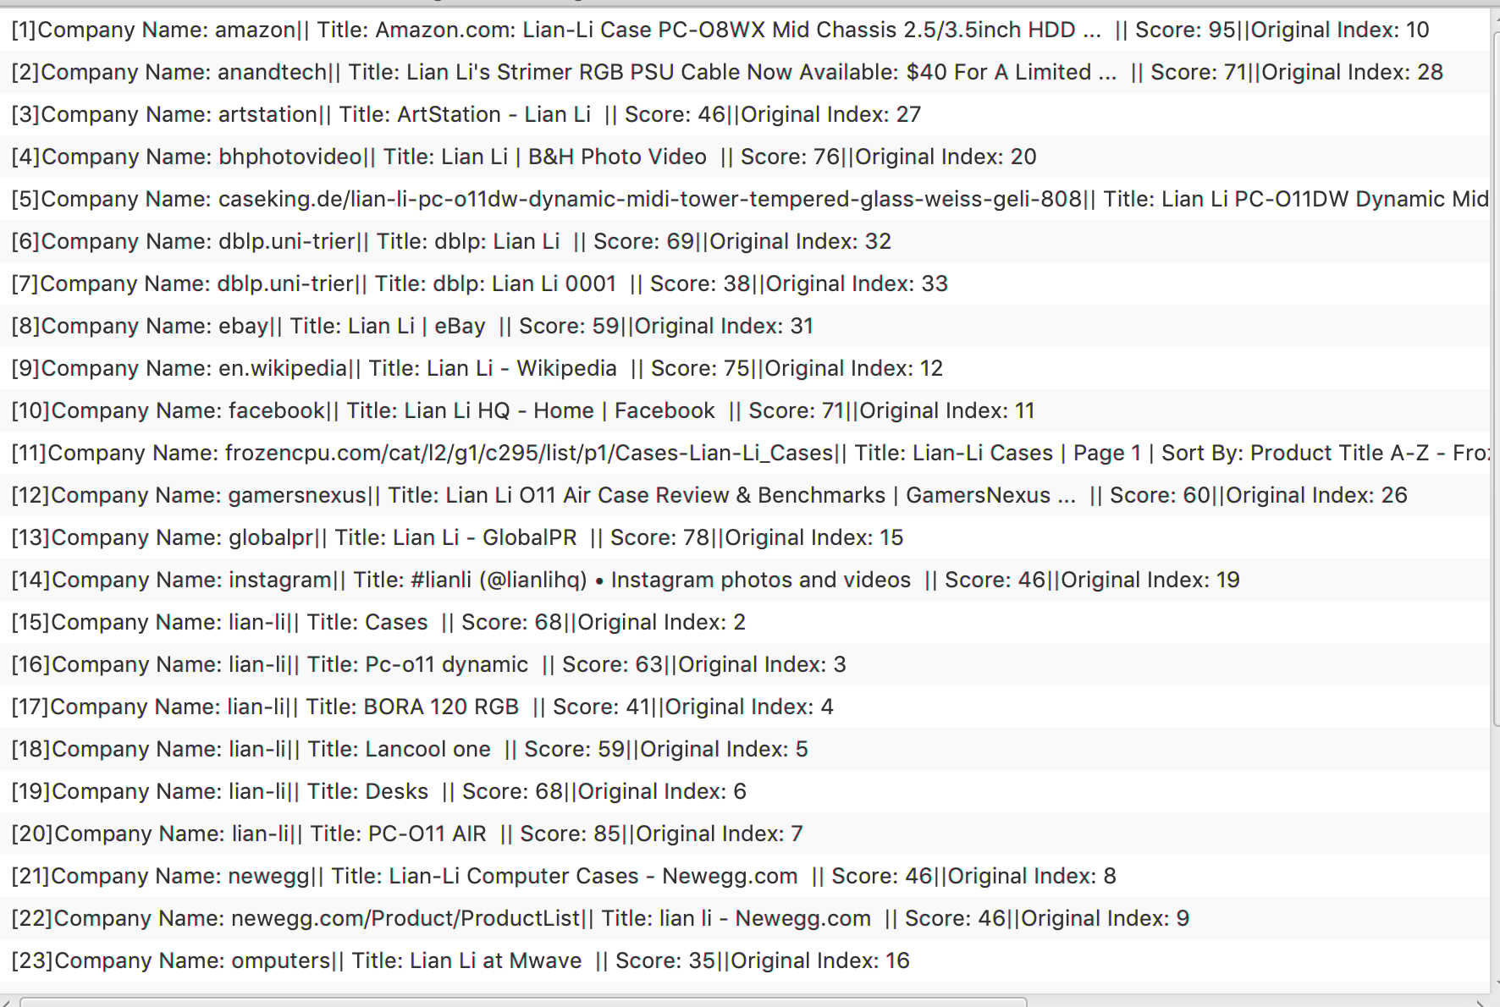

As we can see, the company name is in the alphabet order with original index.

**6) Problems**

* Implement ArrayList of objects needed to slightly change the code from the textbook, but eventually pretty much match what the pseudo code.
* Button, Text Field and List View are hard to organized and put with increasing difficulties of requirements.
* Storing results to 3 different data structure is hard to manage to configure.
* Hard to test with custom data, because all of my design is built up within the UI, more method needed. I should test it and getting all the test data before I implemented into the UI

**7) Learnings**

* Be able to figure out the bugs in BST, Quicksort and bucket Sort implementations.
* Understand more the JavaFX and able to set up basic UI.
* First time writing the programming report, so it helps me understand more what I did, how I did and what should I do to make a better version of the assignment.
* In order to have a better program, I need to test all of the functions before I implement into the UI.